From: http://davidstockmanscontracorner.com/trumpian-boom-r-i-p-part-1/

Trumpian Boom, R.I.P. (Part 1)
By David Stockman. Posted On Tuesday, January 15th, 2019
Well, that didn't take so long. We are referring to last summer's allegedly red-hot Trumpian Boom, which now looks to be heading for the showers. And not just because of the prolonged government shutdown, as we explain below.
As to the shutdown, however, even the Trump Administration---probably in an amateurish ploy to blame the Dems---has doubled its estimated real GDP impact to negative 0.1% per week. That would amount to about a half-point reduction for the quarter if the shutdown ends before the SOTU (state of the union) as expected; or well more than a full percentage point, if it goes the full monte (90 days).
Not surprisingly, the ever ready Wall Street Keynesians, who have a fatal attraction for paint-by-the-numbers faux economics, are already racing to mark-down the Q1 number. Mark Zandi of Moody's, who never saw an economic hiccup he couldn't quantify and model, says that in the event of a full monte shutdown:
We estimate (the shutdown) will reduce first quarter real GDP growth by approximately 0.5 percentage points," Zandi wrote in a research report. "Of this, about half will be due to the lost hours of government workers, and the other half to the hit to the rest of the economy."
We don't intend to debate the point, but would wager bigly that the implied 168 million lost hours (380,000 workers actually furloughed and staying home X 441 hours per quarter/worker at gubermint work schedules) might well result in higher economic output in the real world (as opposed to the GDP accounts), not a loss of GDP.
Still, Zandi's estimate is Keynesian GDP accounting for you. Government spending unequivocally wastes economic resources and shrinks real wealth---especially the current $720 billion of defense spending, which produces no useful or monetized consumer or capital goods, even if it does arguably protect national security.
Then again, there is no nation on the planet today that has even remote capacity to invade the North American continent. So you could scrap the Navy's massively expensive to build and operate 11-carrier battle groups and there would be no diminution of national security whatsoever. Besides, these $13 billion per carrier white elephants can be given a permanent berth in Davy Jones' Locker with a modern missile that costs perhaps $13 million.
You can say the same thing about
- Community Development Block Grants ($3.5 billion),
- Head Start ($10.0 billion),
- mass transit operating subsidies ($10.6 billion), the
- Drug Enforcement Administration ($3.4 billion), the
- Army Corps of Engineering dredging and water projects ($4.8 billion) and
- countless more.
None of these programs remotely achieve their stated objectives and mostly either waste resources, subsidize inefficiency or displace what would otherwise be spent by the private sector or lower levels of government.
Nevertheless, by Keynesian GDP accounting the above named $32 billion worth of programs---measured as the labor, materials and capital inputs spent---equate to exactly $32 billion of GDP. So this is either a case of garbage-in, garbage-out or you have to start wondering about the whole quarterly (or even annual) GDP accounting game.
That is, when you see how government GDP is made---and much of private services GDP is no more compelling---you needs begin taking with a grain of salt Wall Street or Washington claims that a 2.9% seasonally adjusted annualized rate of real GDP gain is "gangbusters" while a 1.5% rate of the same should be dissed as punk.
Moreover, it's not just the government sector (which accounts for 20% of GDP) that is so squirrelly. In the case of the private services sector (which is allegedly where the future is at) there is more of the same. Fully $3.1 trillion or 15% of reported annual GDP is "imputed", and most of that represents purported private services.
For instance, $1.4 trillion of this reflects an imputation (theory based guestimate) for "owner occupied housing". That is to say, the value that a homeowner would charge for renting out his castle to a third party---if he had some other place to live!
Likewise, the GDP accounts include $578 billion annually (i.e. 130% of the total GDP of our alleged Iranian state enemy) for "financial services furnished without payment". That huge guesstimate reflects free checking account services or borrower support services that are not specifically fee charged, and is derived by analyzing what banks spend to provide these services.
Or on the national income side (which always balances with GDP or spending), there is $738 billion (roughly the GDP of Turkey) for employer contributions for in-kind compensation such as free lodging, food services, life insurance, health insurance and much more.
Yes, there is a decent amount of logic for some of this and it all comes out in the complicated wash of the national income and products accounts (NIPA), where the cumulative errors and omissions may or may not be self-cancelling.
But here's the thing. On a short-term quarterly basis or even annually, they should actually outlaw the use of decimal points in the GDP numbers. A four-quarter moving average to the nearest whole percentage point is about as go0d as it can get. That is, the rolling growth average might be strong (5%), moderate (3%) or weak (1%).
The rest of it is a bunch of spurious precision---a lesson we learned back in the day during a White House budget briefing.
Upon the completion of what we thought was a particularly detailed and compelling presentation, the dean of cabinet officers in the Reagan Administration, former labor economics professor, Secretary of Labor, OMB director and Secretary of State, George Shultz, commended our graphs and charts but insisted that in future presentations all budget numbers be rounded to the nearest $10 billion!
The Gipper was much relieved to hear that suggestion, although he soon realized that even rounding down to the big figure of ten billions wouldn't materially minimize the tsunami of red ink that his policies had unleashed.
So when we hear that the economy was red hot last summer and is now heading for the dumpers, we are inclined to look at multi-year averages and round them to the nearest integer that makes sense. Otherwise, you end up like another Keynesian gummer who averred this morning that we are heading for negative real GDP in the current quarter:
A more ominous forecast, that from Pantheon's chief economist Ian Shepherdson, sees the combination of the shutdown and the tendency of the first quarter to be statistically weaker than the other three potentially pushing Q1 GDP growth negative. "If the shutdown were to last through the whole quarter, we would look for an outright decline in first quarter GDP," Shepherdson wrote in a report.
Needless to say, what we are actually heading for is an economy that gets shocked into recession by another panic in the C-suites, which we believe will happen when the current short-covering, algo-driven rebound exhausts itself, and a renewed plunging of the stock averages causes a new round of lay-offs, inventory liquidations and sweeping "restructuring" plans.
In the meanwhile, it is important to note that despite the Wall Street sell-side narrative and the Trump Administration's self-congratulatory patter, the US economy:
- has no momentum from the Trump tax cut---because most of it went to the top 1% and 10% of households, which got a temporary reprieve on the vastly inflated value of their stock-holdings due to massive buybacks and dividend increases in 2018;
- is now just four months from the longest expansion in recorded US history (119 months during the 1990s) and is barely inching forward at 2%/annum;
- is facing growing headwinds from a rapidly cooling global economy led by palpable weakness in China, South Korea, Germany and a long string of other also-rans;
- is about to get monkey-hammered by the next up-ratchet from the Trump tariffs, which will be going up to "enforce" a Washington-style Trade Nanny "framework of agreement" that will remain in permanent negotiations (until someone starts shooting); and
- most importantly, a fiscal conflagration/debt ceiling crisis in Washington that will make the current Border War shutdown look like a Sunday School picnic.
So let us restate the big picture themes:
(1) Presidents don't make the US economy grow----private businessmen, workers, entrepreneurs, investors, savers and speculators do; and
(2) central banks do not stimulate main street prosperity---they just inflate financial asset prices and falsify pricing signals in the capital and money markets, thereby reducing real wealth over time.
In the that context, what is happening is that the soon-to-be longest but weakest business expansion in history is coming to an end owing to the heavy burden of public and private debt ($70 trillion) and the destructive weakening of the main street economy that has resulted from $15 trillion of Fed fostered financial engineering (stock buybacks, M&A deals, leveraged recaps and borrowed dividends) over the last 10 years.
Needless to say, those oppressive forces held down the natural growth capacity of American capitalism on an equal opportunity basis during both the Obama and Trump tenures in the Oval office.
In the comparison below, there is no material difference between the last 11 quarters of the Obama Administration and the results on the Trump watch to date.
During the first seven quarters on the Donald's watch, real final sales (GDP less inventory swings) have actually grown at just 2.69% per annum, and that's no material acceleration at all from Obama's final 11 quarters when the growth rate had been 2.53%.
Indeed, if there was ever a measure of the Trumpian delusion, the above referenced 0.16% of statisticaly meaningless incremental growth is surely it.
So loudly taking ownership of what candidate Trump had correctly called a "big, fat, ugly bubble" was not merely short-sighted and outright dumb; it was actually profoundly insulting to the left-behind voters of Flyover America who elected him.
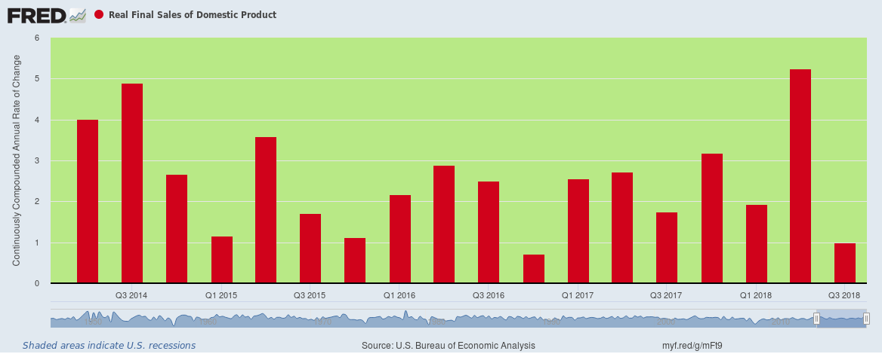
Moreover, the lack of difference is not because Obama's policies have any particular virtue; they were, in fact, a complete disaster.
But Trump did not address the underlying cause of the US economy's growing stall-out: Namely, the central banking policies which have turned Wall Street into a rapacious casino and which has burdened taxpayers, households and government with unsustainable debts.
Now it is too late, as we will address in Part 2. The global breakdown of Bubble Finance is fast closing in on the American economy and the Donald's fragile hold on office.
In a word, there was not Trumpian Boom on main street and the Trumpian Bump on Wall Street is a speculative disaster waiting to crash.

